PeopleXD|People Management: Continuous Service

Contents
Document Version Control 1
Approved process for raising 2
Consultation & Approval 2
Change Management 2
How to 3
Testing 4
Communications 4
Downstream Systems & Processes 4
Affected Reports 4
Additional Background Information 4

Document Version Control
Change History/Review Details
Date | Version | Review by | Summary of Change
17/02/22 | 1.0 | Simon Burford | Initial draft
5 Apr 2023 | 2.0 | Helen Child | Updated to add further clarification

Approved process for raising
Does the change need to be raised through a particular route or by a particular person/team? Are there any actions which need to be taken or considered prior to processing in the HRIS Support Centre?
PeopleXD holds rules which determine whether or not a given appointment is eligible to be counted towards an employee’s Continuous Service. Those rules must be aligned with the University’s policy around Continuous Service and should be updated whenever this policy changes or any aspect used within the configuration is added to.
The configuration has been set up so that there shouldn’t need to be any reconfiguration required when new departments are raised within the main University structure. However, any new "Societies" will need business change to consult on whether the department qualifies for continuous service. If the new department code qualifies this will require a change to the continuous service configuration.
There may be a need to review the configuration if any of the related items have a new reference data added, such as Employee Status, Sub Division or the Marie Curie Student pay scale. These are covered within the relevant knowledge article / process document, so normally changes to continuous service will be a result of an upstream change.
There may be a policy change which redefines who is eligible for continuous service or the break in service rules. This would need to be raised by the HR Policy Team and confirmed by the Business Change team.

Consultation & Approval
Who is the owner of this information? Who needs to be consulted about this change before you begin work on it? Does anyone need to approve this change before it is implemented?
Any queries relating to continuous service eligibility and rules will need to be confirmed by the Business Change team before implementation. They may need to consult HR Business Partners or HR Policy as relevant.
The confirmation should be attached to the change request

Change Management
What type of change is this? When should approval be sought and from whom (internal to team or change manager)? Who would normally be responsible for implementing?
Minor change request to be approved by the Head of HR Systems

How to
Technically how to process the change in the system
Changing the Continuous Service configuration
A how to guide on how to amend the continuous service configuration can be found here:
P:\PROJECTS\HRIS Programme\12. Support\Reference Data\How to guides\HOW TO - Maintain Continuous Service Eligibility Rules in the Portal.docx

Testing
Who would normally be responsible for testing? Are there standard items to test?
Check continuous service for employees affected by the changes, employees transferring in and out of eligible appointments.
Also check the impact on long service awards for additional annual leave within Core Time, if the changes affect employees live with annual leave configuration.

Communications
Who needs to be informed (but not consulted) about this change? Detail when they should be informed (before or after the change).

Downstream Systems & Processes
Details of any processes which are affected or need to be carried out following, or as part of, the change. Please detail any triggers, actions required and when the actions should be carried out.
When making a change to the configuration of continuous service you must update the configuration document and record information within the final decisions and config document, stored here:
P:\PROJECTS\HRIS Programme\12. Support\Continuous Service
Any business decisions around eligibility should also be recorded in the ‘Staff Groups in Core’ document managed by the Business Change team. This may then need to be published online in the ‘People Profile Matrix’.

Affected Reports
Are there any standard reports which may need to be updated following this change?

Additional Background Information
Any other relevant information, links to supporting documentation etc.
It is worth noting that continuous service rules impact on CoreTime long service annual leave configuration, this is separate but any changes to rules here will impact long service for staff impacted by the change.
Notes from Access Group knowledge article indicate that the CS at employee level will only be re-calculated for employees where there has been an update to the appointment, updates to rules themselves won’t cause a re-calculation:
Continuous Service (CS) will be calculated by a nightly database job for employees, based on the Service Rules configured.
This will review all employee records on HR and compare them to the service rules defined.
If an employee meets the eligible service rule criteria, a CS Start Date will be stored for that employee.
To see the rules that are defined:
- Click CorePersonnel, Reference, Reference Q-Z, Service Rules, Eligible Service Rules.
- Use the drop-down and select Continuous Service
- The calculation of continuous service dates will be triggered on:
  - Commencement of a Post Appointment
  - Update of Commenced or Ended Post Appointment
  - End of Post Appointment
Confirmed Future Appointment will not impact CS dates. Once the Appointment is Commenced it will.
It will allow for Override dates & TUPE dates to be entered manually, which can override the overall Continuous Service Duration calculation.
- Notes from an Access Group knowledge article explaining the fields included in the Continuous Service screen
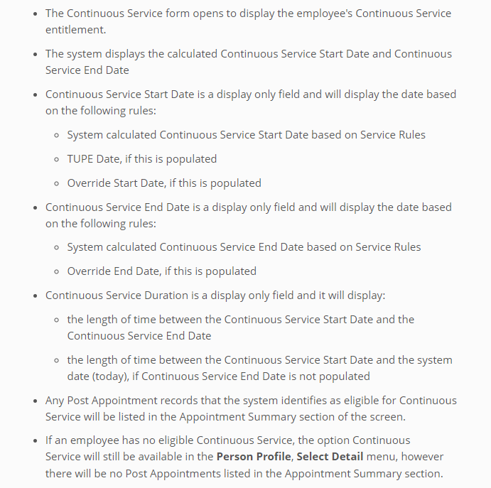

- Continuous service dates matrix
A matrix showing all of the continuous service fields plus service dates and length of service and where they appear in the system can found here.

